**SSN COLLEGE OF ENGINEERING, KALAVAKKAM  
DEPARTMENT OF COMPUTER SCIENCE AND ENGINEERING  
UCS1712 – GRAPHICS AND MULTIMEDIA LAB ------------------------------------------------------------------------------------------------------------**

**Lab Exercise 3 : Bresenham Line Drawing Algorithm in C++ using OpenGL**

**Aim:**

To perform Bresenham line drawing algorithm in C++ using OpenGL

**Algorithm:**

procedure lineBres (xa, ya, xb, yb : integer) var

dx,dy,x,y,xEnd,p:integer; begin

* dx:=abs(xa-xb);
* dy:=abs(ya-yb);
* p:=2*dy–dx;
* ifxa>xbthen  
   begin  
   x:= xb;  
   y:= yb;  
   xEnd := xa;
* else
* begin  
   x:=xa;  
   y:=ya;

Contd...

* xEnd := xb;
* end;
* setPixel (x,y,1);
* while x < xEnd do
* begin
  + x:=x+1;
  + ifp<0thenp:=p+2*dy
  + else  
    begin y:=y+1;  
    p:=p+2 * (dy-dx) end;  
    setPixel (x,y,1); end  
    end; {lineBres}

**To plot points that make up the line with endpoints (x0,y0) and (xn,yn) using the Bresenham line drawing algorithm.**

Case 1: +ve slope Left to Right line  
Case 2: +ve slope Right to Left line  
Case 3: -ve slope Left to Right line

Case 4: -ve slope Right to Left line

Each case has two subdivisions -

**(i) |m|<= 1 (ii) |m|>1  
Note that all four cases of line drawing must be given as test cases.**

***Source Code:***

#include<GLUT/glut.h>

#include<iostream>

#include<cmath>

#include<string>

using namespace std;

void drawString(float x, float y, const char *string){

glRasterPos2f(x, y);

for(const char* c = string;*c!='\0';c++)

glutBitmapCharacter(GLUT_BITMAP_HELVETICA_12, *c);

}

void myInit() {

glClearColor(1.0,0.6,0.5,0.0);

glPointSize(1);

glMatrixMode(GL_PROJECTION);

glLoadIdentity();

gluOrtho2D(0.0,480.0,0.0,480.0);

}

void myDisplay() {

glClear(GL_COLOR_BUFFER_BIT);

int x1,y1,x2,y2,dx,dy;

float x,y;

cout<<"Enter x1, y1, x2, y2: ";

cin>>x1>>y1>>x2>>y2;

glColor3f(0.0,0.0,0.0);

glBegin(GL_POINTS);

glVertex2f(x1,y1);

glEnd();

dx=x2-x1;

dy=y2-y1;

float m=(float)dy/dx;

int p=(2*dy)-dx;

int c=dx;

int d=dy;

cout<<"Slope = "<<m<<endl;

// +ve slope

if(m<=1 && m>=0){

x=x1;

y=y1;

int t1=c;

while(t1--)

{

if(p<0)

{

x=x+1;

p=p+(2*dy);

glColor3f(0.0,0.0,0.0);

glBegin(GL_POINTS);

glVertex2f(x,y);

glEnd();

}

else{

x=x+1;

y=y+1;

p=p+(2*dy-2*dx);

glColor3f(0.0,0.0,0.0);

glBegin(GL_POINTS);

glVertex2f(x,y);

glEnd();

}

}

}

if(m>1){

x=x1;

y=y1;

int t2=d;

while(t2--)

{

if(p<0)

{

y=y+1;

p=p+(2*dx);

glColor3f(0.0,0.0,0.0);

glBegin(GL_POINTS);

glVertex2f(x,y);

glEnd();

}

else{

y=y+1;

x=x+1;

p=p+(2*dx-2*dy);

glColor3f(0.0,0.0,0.0);

glBegin(GL_POINTS);

glVertex2f(x,y);

glEnd();

}

}

}

//-ve slope

if(dx<0)

{

dx*=-1;

}

if(dy<0)

{

dy*=-1;

}

p=(2*dy)-dx;

if(m*(-1)<=1 && m*(-1)>=0){

x=x2;

y=y2;

int t4=dx;

while(t4--)

{

if(p<0)

{

x=x-1;

p=p+(2*dy);

glColor3f(0.0,0.0,0.0);

glBegin(GL_POINTS);

glVertex2f(x,y);

glEnd();

}

else{

x=x-1;

y=y+1;

p=p+(2*dy-2*dx);

glColor3f(0.0,0.0,0.0);

glBegin(GL_POINTS);

glVertex2f(x,y);

glEnd();

}

}

}

if(m*(-1)>1)

{

x=x2;

y=y2;

int t3=dy;

while(t3--)

{

if(p<0)

{

y=y+1;

p=p+(2*dx);

glColor3f(0.0,0.0,0.0);

glBegin(GL_POINTS);

glVertex2f(x,y);

glEnd();

}

else{

y=y+1;

x=x-1;

p=p+(2*dx-2*dy);

glColor3f(0.0,0.0,0.0);

glBegin(GL_POINTS);

glVertex2f(x,y);

glEnd();

}

}

}

drawString(x1,y1,("("+to_string(x1)+","+to_string(y1)+")").c_str());

drawString(x2,y2,("("+to_string(x2)+","+to_string(y2)+")").c_str());

glFlush();

}

int main(int argc,char* argv[]) {

glutInit(&argc,argv);

glutInitDisplayMode(GLUT_SINGLE|GLUT_RGB);

glutInitWindowSize(480,480);

glutCreateWindow("Bersenham Algorithm");

glutDisplayFunc(myDisplay);

myInit();

glutMainLoop();

return 1;

}

***Output:***

***Case 1: +ve slope Left to Right line***

***m>1***

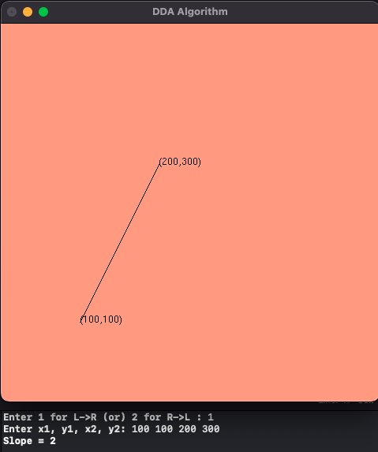

***m<=1***

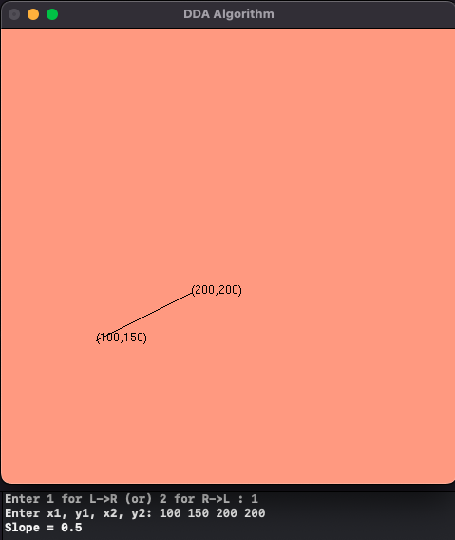

***Case 2: +ve slope Right to Left line***

***m>1***

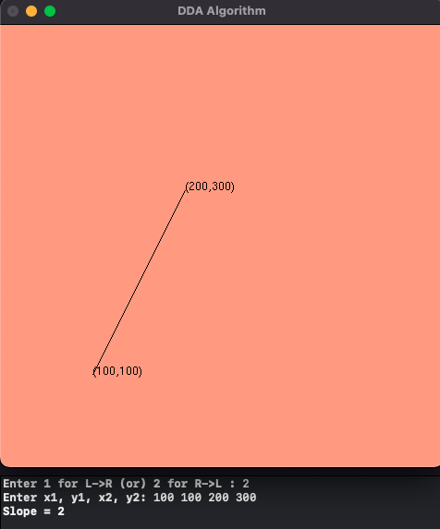

**m<=1**

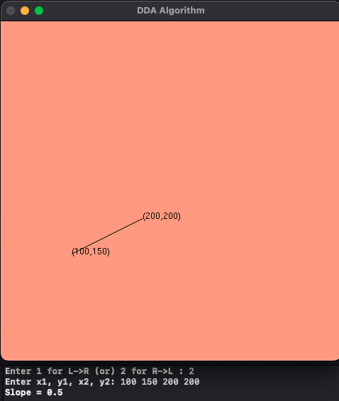

**Case 3: -ve slope Left to Right line**

**m>1**

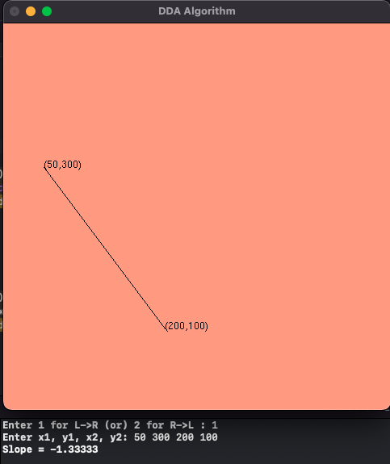

**m<=1**

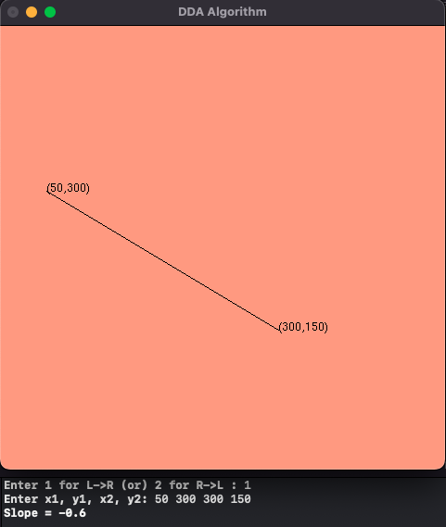

**Case 4: -ve slope Right to Left line**

**m>1**

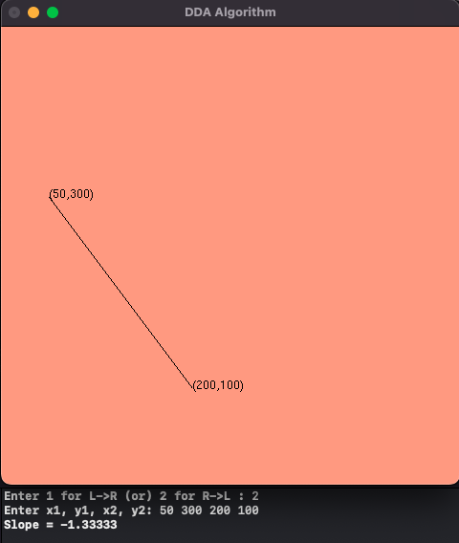

**m<=1**

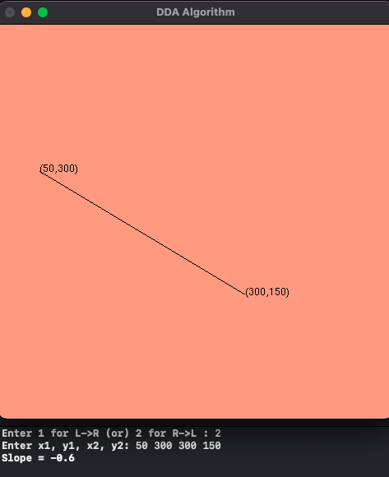

**Learning Outcome;**

Learnt how to perform Bresenham algorithm in C++ using OpenGL